NSS Tutorial

1. SELECT A_STRONGLY_AGREE FROM nss WHERE question='Q01' AND institution='Edinburgh Napier University' AND subject='(8) Computer Science'

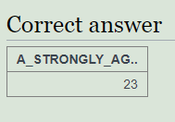

1. SELECT institution, subject FROM nss WHERE question='Q15' and score >= 100

|  |  |
| --- | --- |
| **institution** | **subject** |
| Kingston College | (I) Education |
| Royal Holloway, University of London | (L) Geographical Studies |
| Solihull College | (I) Education |
| Stafford College | (D) Business and Administrative studies |
| University of Southampton | (E) Mass Communications and Documentation |
| University of Wolverhampton | (7) Mathematical Sciences |
| University of Leicester | (2) Subjects allied to Medicine |
| University of Newcastle upon Tyne | (E) Mass Communications and Documentation |
| Bishop Grosseteste University College, Lincoln | (F) Languages |
| University of Dundee | (L) Geographical Studies |
| Universities of East Anglia and Essex; Joint Provision at University Campus Suffolk | (G) Historical and Philosophical studies |

1. SELECT institution,score FROM nss WHERE question='Q15' AND score < 50 AND subject='(8) Computer Science'

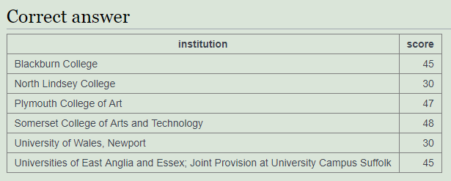

1. SELECT subject,sum(response) FROM nss WHERE question='Q22' AND subject in ('(8) Computer Science','(H) Creative Arts and Design') group by subject

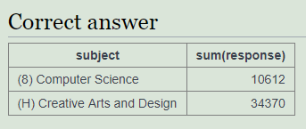

1. SELECT subject,sum(response * A_STRONGLY_AGREE / 100) FROM nss WHERE question='Q22' AND subject in ('(8) Computer Science','(H) Creative Arts and Design') group by subject

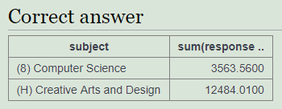

1. SELECT subject, ROUND(sum(response*A_STRONGLY_AGREE)/SUM(response)) FROM nss WHERE question='Q22' AND subject in ('(8) Computer Science','(H) Creative Arts and Design') GROUP BY SUBJECT

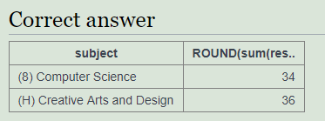

1. SELECT institution,ROUND(sum(score*response)/SUM(response)) FROM nss WHERE question='Q22' AND (institution LIKE '%Manchester%') GROUP BY institution

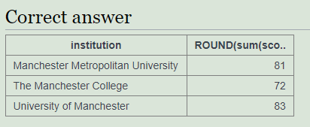

1. SELECT institution,sum(sample), sum(CASE WHEN subject like '%Computer Science%' THEN sample ELSE 0 END) FROM nss WHERE question='Q01' AND (institution LIKE '%Manchester%') group by institution

